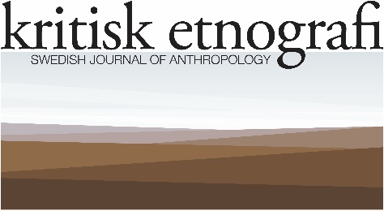

Call for papers to 2024, Vol 7, Issue 2 of kritisk etnografi: Swedish Journal of Anthropology
Launched in 2018, the journal has so far published six volumes with two issues per year. In 2024, we plan to publish a Varia, that is, a non-thematic issue bringing together diverse papers when it comes to thematic and/or geographical orientation. To do this, we need contributions from our readers and colleagues. We look for papers that use ethnography critically to discuss topics that have a potential to bring broad audiences into engagement with anthropological perspectives. This is also a great opportunity to make your research known in Swedish as well as international contexts.
kritisk etnografi – Swedish Journal of Anthropology is an independent journal run by researchers, and as such, it presents a tangible alternative to the business model of commercial publishers. The journal is peer-reviewed, online, open access without any costs for authors or readers, and publishes original research articles, as well as reports from Swedish anthropological community. It is owned and published by the Swedish Society for Anthropology and Geography (Svenska Sällskapet för Antropologi och Geografi).
For a detailed description of the journal’s profile and objectives, please visit our web site here. To widen the exposure of the journal, hard copies are produced of each volume that can be purchased here; they are also distributed by Amazon, Bokus, Adlibris, etc.

Please send your paper to editors@kritisketnografi.se, on 1 April 2024 at the latest. We will then embark in the usual review process and plan to be able to take a publication decision before Summer 2024, and publication in the Fall 2024.

Prof. Sten Hagberg and Prof. Jörgen Hellman
Editors-in-Chief
kritisk etnografi: Swedish Journal of Anthropology, https://kritisketnografi.se/
editors@kritisketnografi.se

